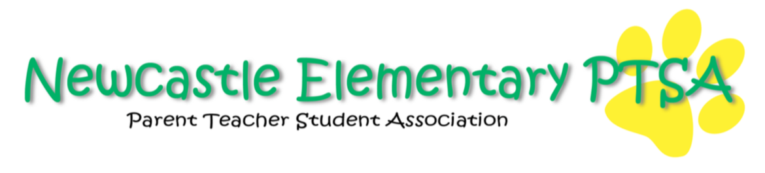2021/2022 Board Planning Agenda Minutes
July 6, 2021, 1:30-3:00
7911 129th Pl SE Newcastle, WA (Mary Vickers’ House)

Attendees: Mary Vickers, Brooke Weller, Mei Atangan, Ali Bligh, Bettina Vuong, Albert Kim (via Zoom), Bisa Meek, Lara Flores, Abigail Hamida (via Zoom)

Introduction and Roles/Expectations
-Review and explanation of roles and expectations
-Ensure training is completed by attending sessions related to your role. Mary will email info on how to access trainings.
-Members submit email to secretary briefly outlining what training they completed
-Reminder to board to renew PTSA membership at EVP
-Ensure members have activated email accounts for current position as there are email addresses for new member roles
-Procedures for check requests reviewed
-Board vote on Check Signers
Check request signers: Mei, Bettina, Abigail, Mary, Bisa
Ali motions to approve the above Check Signers
Bisa seconds the motion and the Board approves Mei, Bettina, Abigail, Mary and Bisa as Check Signers
Mei will email Homestreet Bank to set up time for check signers to go in

Strategic Planning
-Board discussion and review of current Standing Rules
-Board vote on maintaining current Standing Rules
Bisa makes a motion to approve the current Standing Rules
Lara seconds the motion and the Standing Rules have been approved by unanimous vote
-Vote to set Board meeting for August 23 6pm, location TBD
-Discussion of activities in prep for August 23rd meeting
-Potential activities discussed for further discussion at the August planning meeting include: Popsicles on the playground and Meet the Teacher plans. Potential on campus events to be determined. Outdoor and indoor options discussed. KinderConnect schedule outlined below:
Wed 7/28 5:30 Summer playdate, Lake Boren Park
Fri 8/20 5:30 Summer playdate Lake Boren Park
Mon 8/30 Meet the Teacher school wide event
Fri 9/3 first day of kindergarten after student drop off “tissues and tears” for parents if Covid regulations permit

-PTSA volunteer / attend events to ensure inclusiveness of community
-Albert and Bisa in charge of fall events TBD
-Plan for volunteers and potential support (Plan for two scenarios, volunteers allowed on school grounds, and possibility of not)
-Send volunteer needs to Alison and Lara by July 29th so they can put it in EVP

Auction Update
-Need for co-chairs
-March 11, 2023 with Matt Lorch @ Hyatt

Administration
-Board meetings schedule outlined below:
Second Monday of every month in-person and remote
September 13 1:00-3:30
October 11 6:00-7:30
November 8 1:00-3:30
December 13 6:00-7:30
January 10th 1:00-3:30
February 14 1:00-3:30
March 14th 6:00-7:30
April 4th 1:00-3:30
May 9th 6:00-7:30
June 13th 1:00-3:30

-PTSA General meetings (4-5 a year) will be determined once Dr. Wood has input regarding his schedule. Time to be determined.
-Tentative date for Financial Review July 19th 7:00pm

