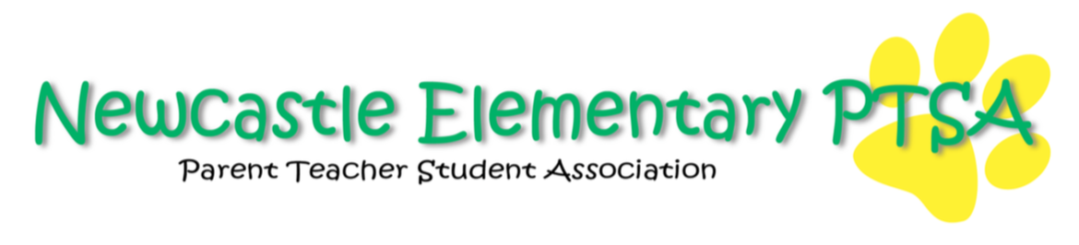
Newcastle Elementary PTSA Board Meeting Minutes
August 23, 2021 6:00-7:20pm
Virtual/Remote Zoom Meeting

Attendees: Mary Vickers, Dr. Wood, Mei Atangan, Ali Bligh, Kelli Medak, Brooke Weller, Marcia O’Donoghue, Abigail Hamida, Lara Flores, Allison Sweeney, Bettina Vuong

Principal Update
-Dr. Wood shared updates on procedures and restrictions for Meet The Teacher Day on August 30th and Curriculum Night September 14th. He also discussed PTSA involvement in facilitating events and Covid-19 processes for mitigating spread on campus.

-Dr. Wood also shared his likely leave of absence in September and will confirm dates once surgery is scheduled.

President Update
-Meet the Teacher will have procedural changes due to mitigating the spread of Covid-19. Student and parental involvement will be limited and outlined in the upcoming E News bulletins. Popsicles on the Playground is canceled; however, means of how the PTSA can connect and communicate with student and parent body were discussed and a potential welcome booth outside of the school was suggested. A PTSA table with a small takeaway gift was also presented as an idea to connect and recruit members and volunteers.
-President suggested updating information and images for current board members as an effort to “Get To Know” the PTSA through social media.

-General Meeting Dates selected:

September 27th 7:00pm | December 6th 7:00pm | February 7th 7:00pm | April 18th 7:00pm | June 6th 7:00pm

Volunteer Update
-EVP was successful as Allison outlined the positions filled. There are still positions available; however, and initiatives were discussed as to how to potentially recruit new members and volunteers to fill these openings. The organization chart details responsibilities of each Board member and the various volunteers who have enlisted to assist.

Ways and Means
-Spirit Wear discussion on logo and the need to get design updates solidified in order to begin the orders and the sale of Spirit Wear.
-Discussion of where previous logo images are stored and shared lead to further discussion as to where and how to store pertinent shareable documents. The creation of a centralized location to access various PTSA shared links, images and documents was discussed. This conversation continued during the Outreach Update update where a possible solution is outlined.

Programs Update
-Update on who is leading the Student Leadership team and what that may look like next year. Dr. Wood informed the Board that more details will follow and that it will be different but potentially more meaningful for students this year.
-Boo Thru/ Costume Carnival potential volunteers discussed
Outreach Update
-Angel Program
Marcia updated the Board on procedures for how to delineate funds and identify students who need assistance. The school counselor will create an anonymous list of students with particular needs and notify Marcia and the Angel Program. Then, the Angel Program can notify the network of volunteers as to how to meet these needs and requests in a fair and balanced way for all students.

-Kinder Connect
-Bettina gave an update on Kinder Connect and noted significant turnout of new families at the August event. She also notified the Board of a new parent Facebook group for kindergarten families.
-Laura was present at the Kinder Connect meetup and mentioned cards she created to disperse to parents in order to recruit potential volunteers. -Discussion as to where to upload such documents to a shared Google drive ended with a decision to create folders for each board position. This way, we can store important documents that would be helpful for those coming into these roles in the future. The Google drive is connected to the newcastleptsa@gmail account.

-Reminder to ensure Board members are all PTSA members was highlighted and that they complete their training as soon as possible. Ensure members notify secretary once they have completed training.

Treasurer Update
-Board reviewed that they have adequate check signers

